Members : [s6abkuma@uni-bonn.de](mailto:s6abkuma@uni-bonn.de)

[s6erbalc@uni-bonn.de](mailto:s6erbalc@uni-bonn.de)

[s6ratyag@uni-bonn.de](mailto:s6ratyag@uni-bonn.de)

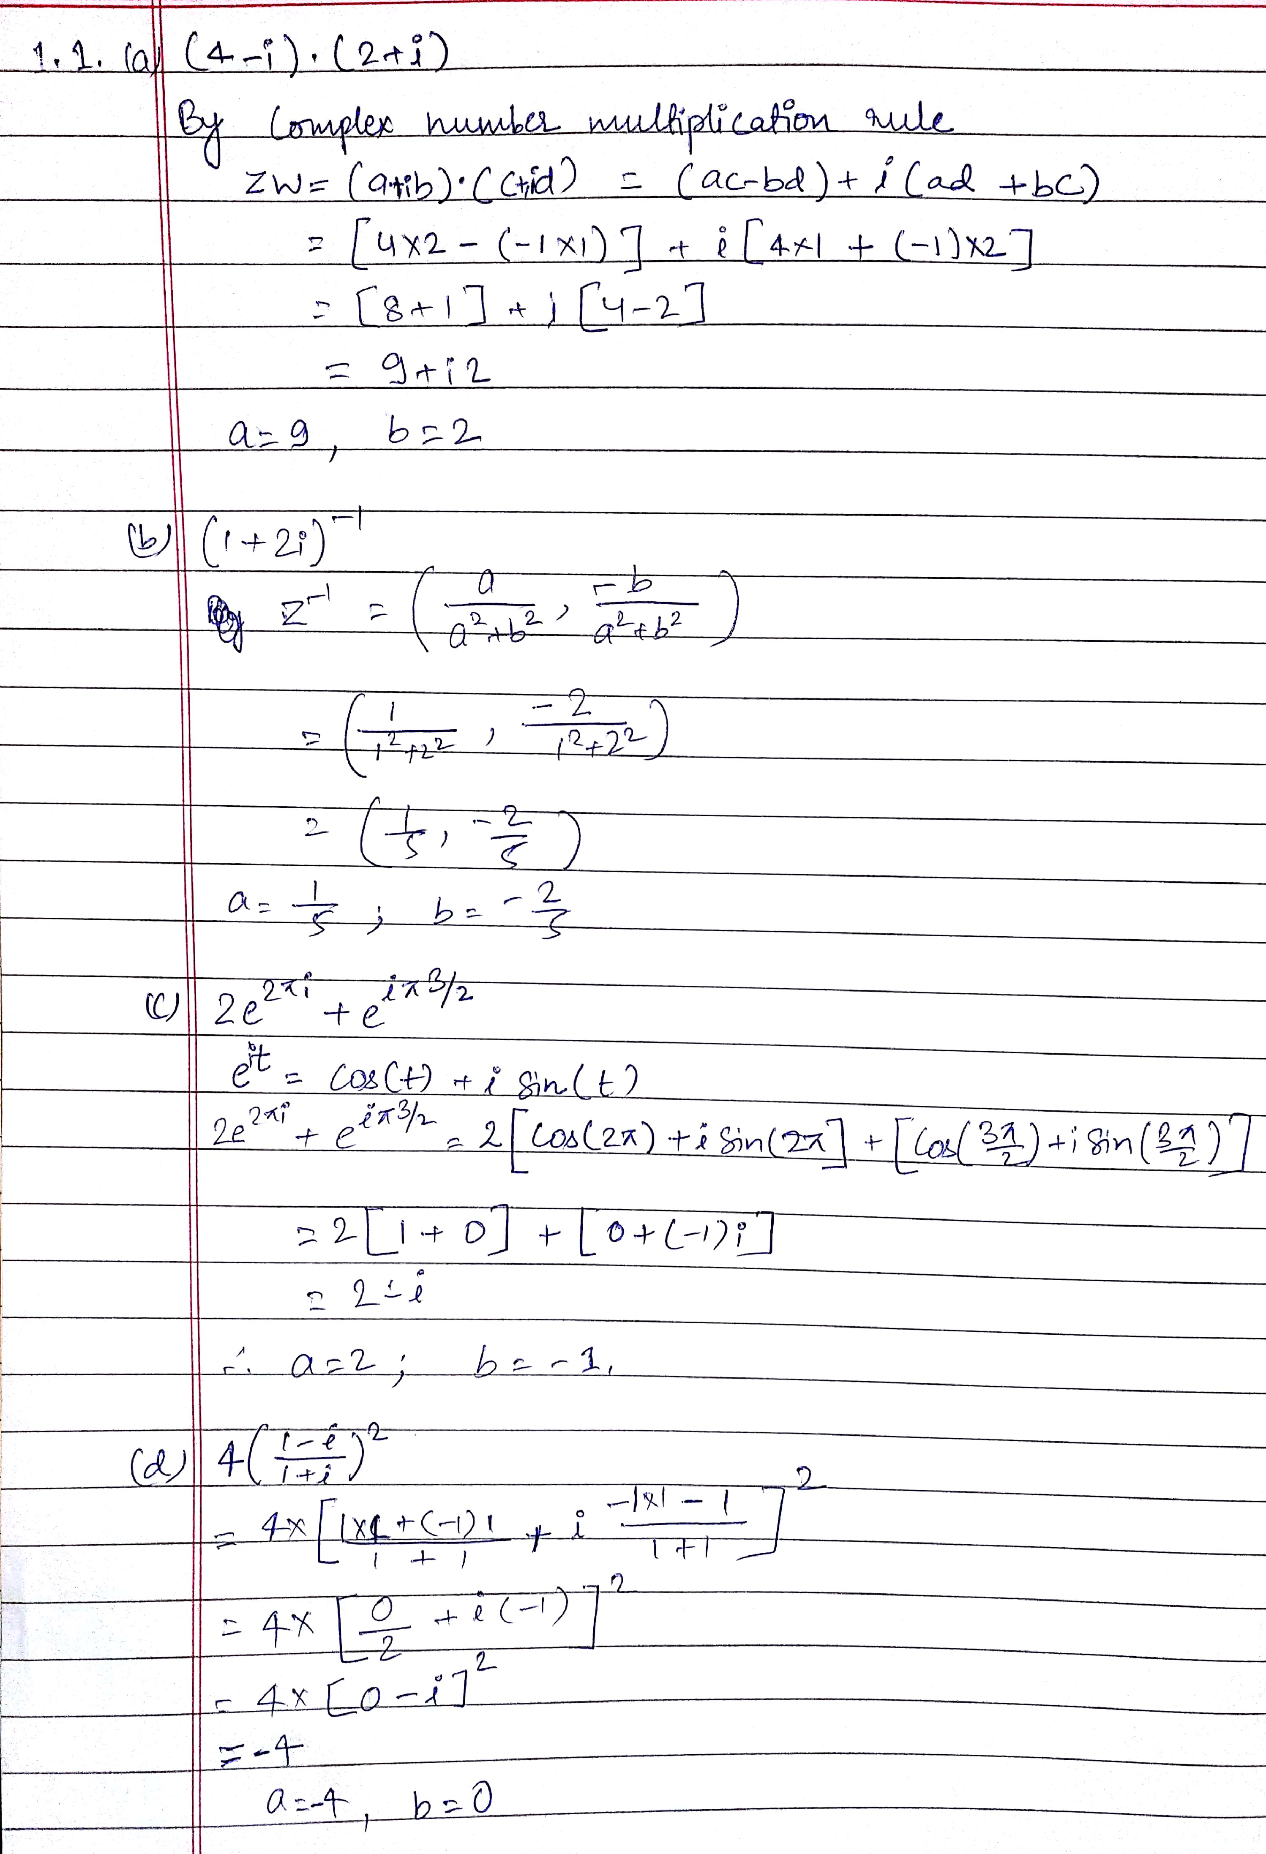

1.2

Screenshot

